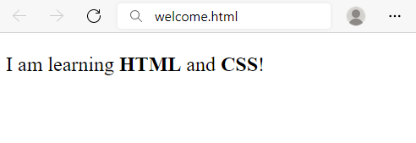
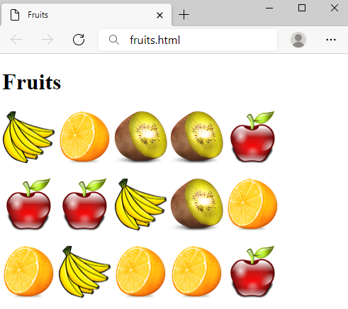
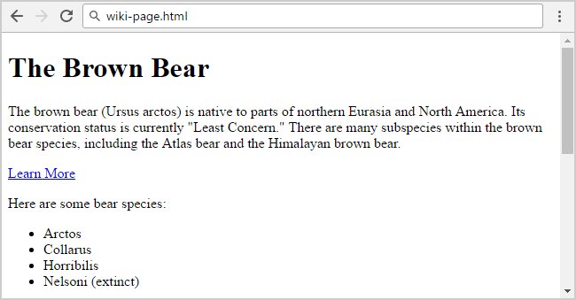
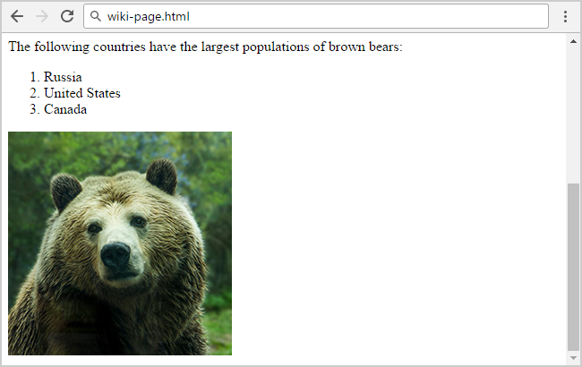
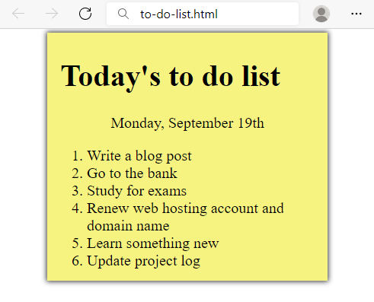
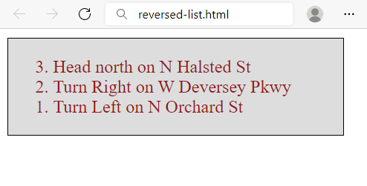
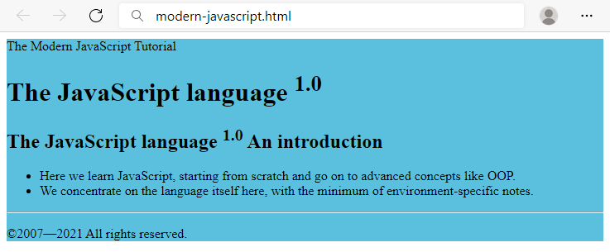
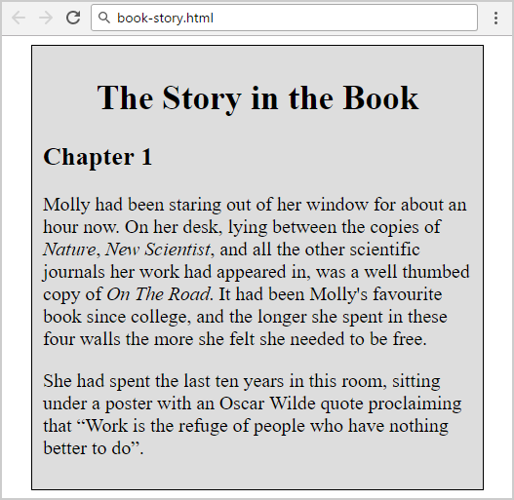
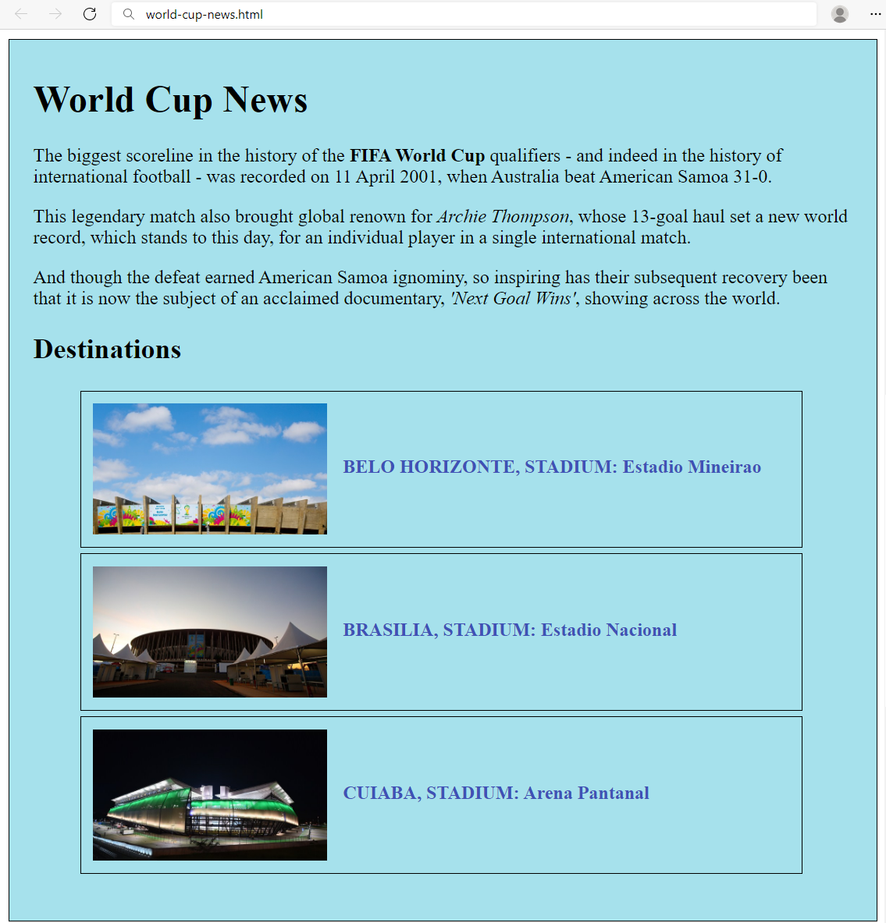
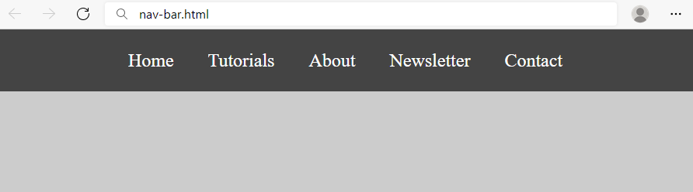
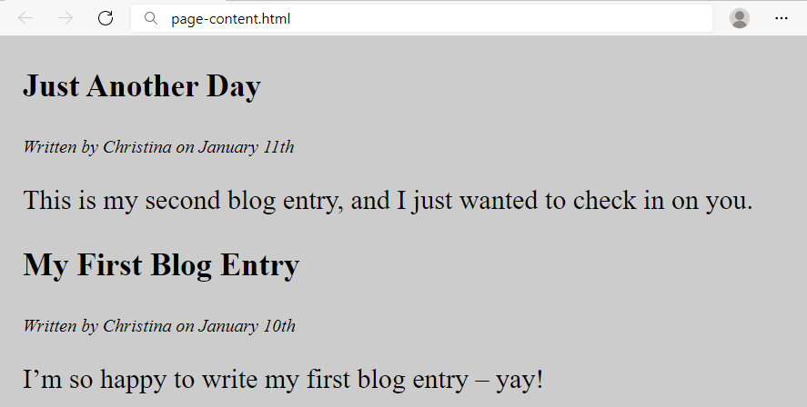
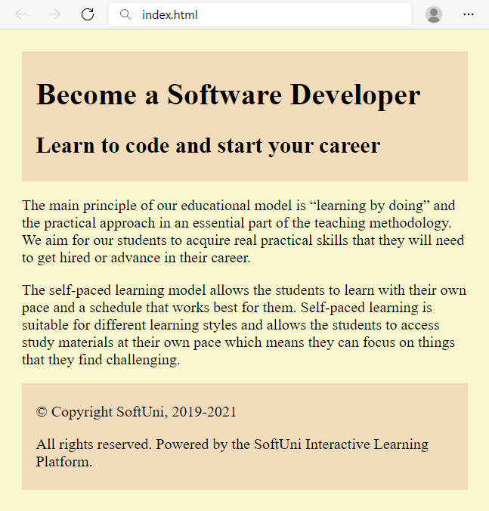
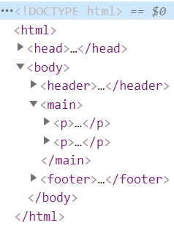
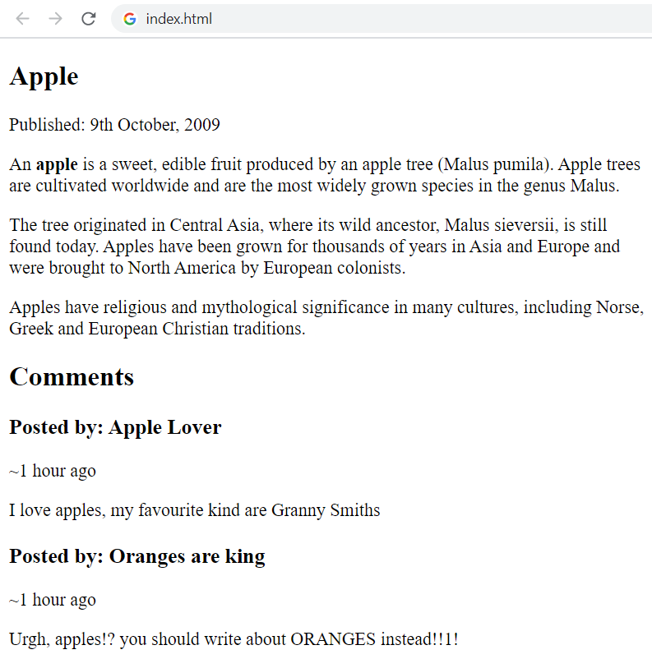
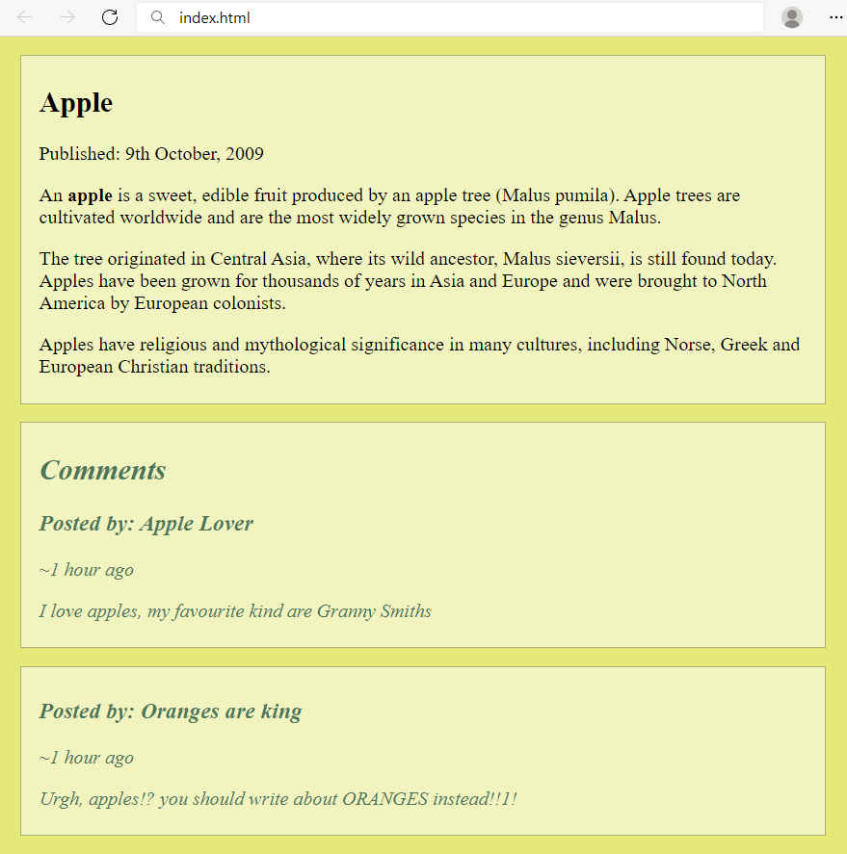
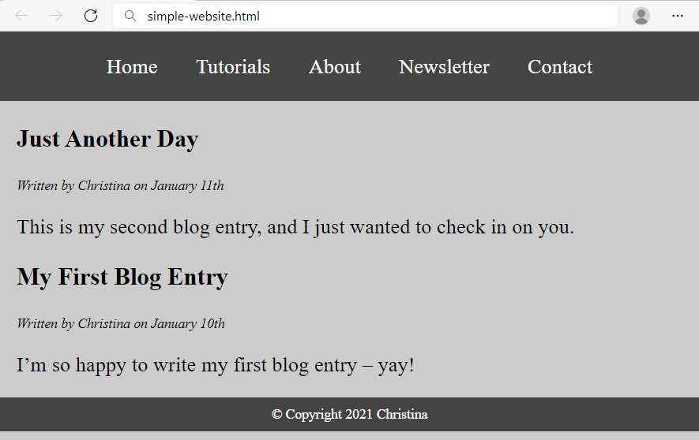
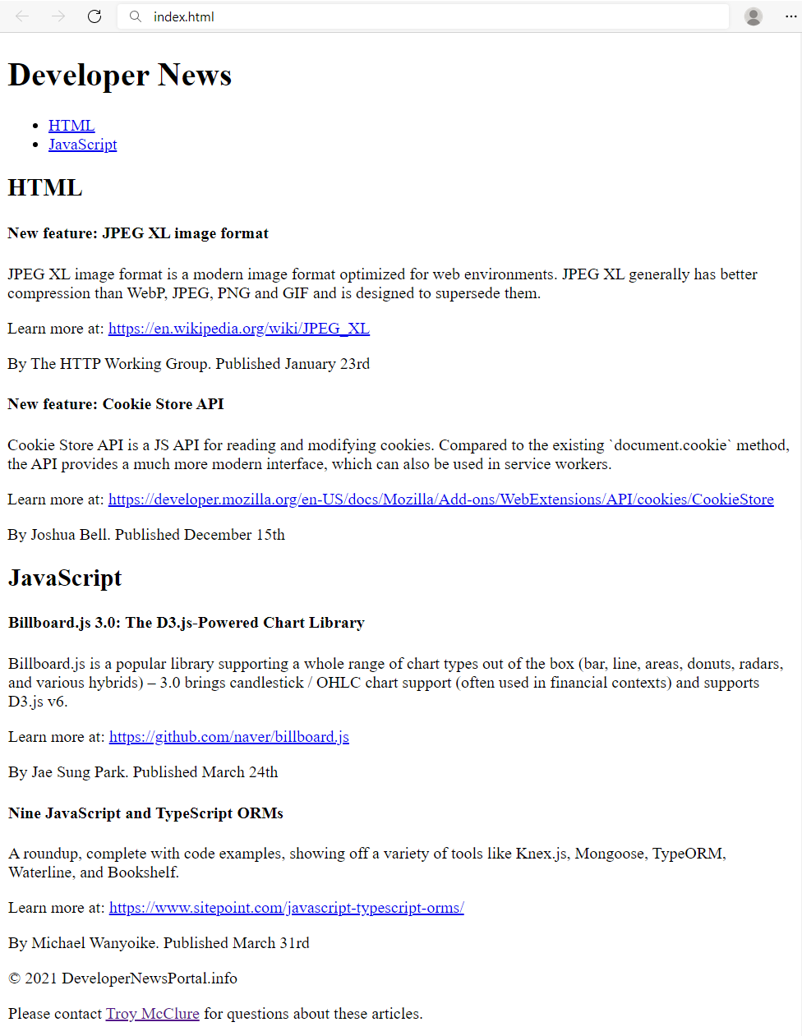
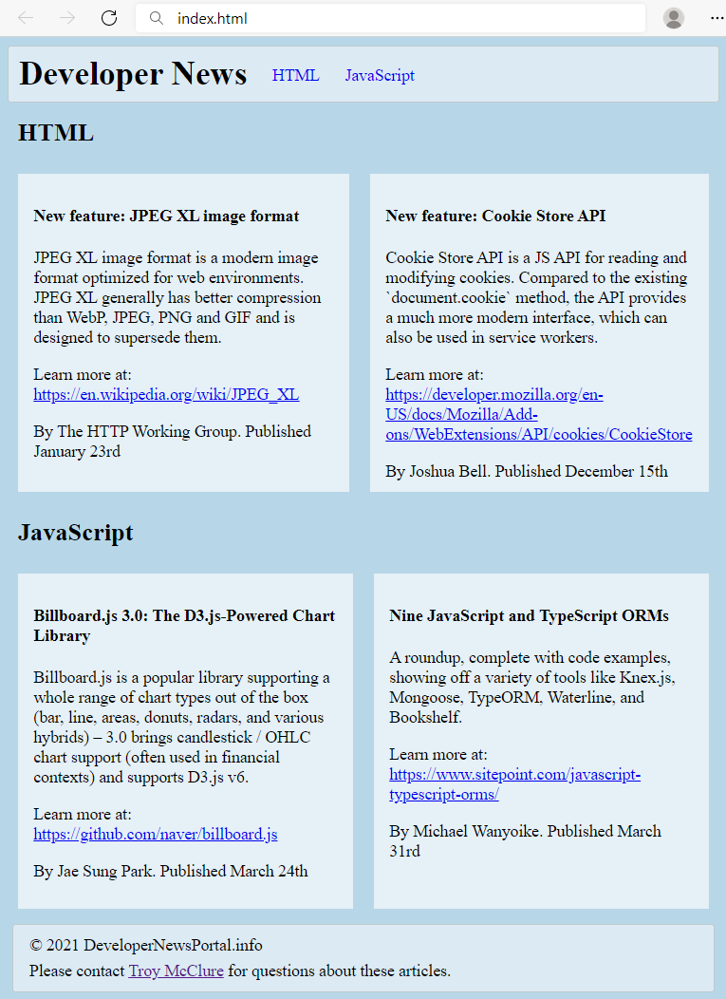

Exercise: Introduction to HTML and CSS
Problems for exercises and homework for the "HTML and CSS" course @ SoftUni.

Welcome to HTML
Create a Web Page like the following:
Create file named welcome.html. Use the texts from the file site-texts.txt.

Requirements
- Title: Welcome
- <strong> tag for bold text
- <p> tag for paragraph

Fruits
Create a Web Page like the following:
Create a file fruits.html.

Requirements
- Titile: Fruits
- <h1> tag for heading
- <img> tag for images

Hints
- Use 3 paragraphs, each holding 5 images

Wiki Page
Create a Web Page like the following:
Create file: wiki-page.html. Use the texts from the file site-texts.txt.

Requirements
- Title: The Brown Bear
  - <h1> for heading
- Hyperlink: https://en.wikipedia.org/wiki/Brown_bear
- Text: use paragraph
- List: use ordered list and unordered list
- Image: bear.jpg

To Do List
Create a Web Page like the following:
Create two files: to-do-list.html and to-do-list.css. Use the texts from the file site-texts.txt. Use the texts from the file site-texts.txt. Set the html title to be the same as the task name.

Requirements
- <main> with class="my-list" as container
  - Background Color: #f7f381;
  - Padding: 8px 24px;
  - Width: 500px;
  - Text size: 30px;
  - Border: 1px solid #f7f381;
  - box-shadow: 0 0 10px 2px #333333;
- <ol>
  - Margin: 12px;
- <p>
  - Center the text

Hints
- Center the container
- Heading: use <h1>
- Date: use <p> + center it
- List: use <ol>

Reversed List
Create a Web Page like the following:
Create two files: reversed-list.html and reversed-list.css. Use the texts from the file site-texts.txt. Set the html title to be the same as the task name.

Requirements
- <main> with id=wrapper as a container
  - Background color: #dddddd;
  - Text color: #95191a;
  - Width container: 300px;
  - Border: 1px solid #000000;

Hints
Use:
- <ol> with reversed attribute
  - <ol reversed="reversed">
- Submit only reversed-list.html + reversed-list.css in ZIP archive file

The Modern JavaScript
Create a Web Page like the following using the texts from site-texts.txt.
Create two files: modern-javascript.html and modern-javascript.css. Set the html title to be the same as the task name.

Requirements
- <main> with id=wrapper as a container
  - Background color: #5bc0de;

Hints
Use:
- <h1> and <h2> tags for headings
- <sup> tag for superscript text
- <p> tag for paragraphs and <span>
- <ul> tag for list items
- <hr /> for horizontal line
- <footer> tag for copyright part + &copy; for copy right symbol

Book Story
Create a Web Page like the following using the texts from site-texts.txt. Set the html title to be the same as the task name.
Create two files: book-story.html and book-story.css. Set the html title to be the same as the task name. Set the html title to be the same as the task name.

Requirements
- <main> for the main container
  - Width container: 400px;
  - Background color: #dddddd;
  - Border: 1px solid #000000;
  - Margin Left: 20px;
  - Padding: 10px;
- <p> tag for paragraph + font-size: 18px;
- <em> tag for italic text

Hints
Use:
- <h1> tag for heading + center the text
- <q> tag for quotation text
  - q::before {
content: open-quote;
}
  - q::after {
content: close-quote;
}

World Cup News
Create a Web Page like the following.
Create two files: world-cup-news.html and world-cup-news.css. Use the texts from the file site-texts.txt. Set the html title to be the same as the task name.

Requirements
- <main> with id= "wrapper" as a container
  - Width container: 700px;
  - Height container: 730px;
  - Border: 1px solid #000000;
  - Center the container
  - Padding: 10px 20px;
  - Background Color: #a6e1ec;
- <h1> and <h2> tags for headings
- <p> tag for paragraph
- <strong> tag for bold text
- <em> tag for italic text
- <img> tag for images
  - Width: 200px;
  - Margin Right: 10px;
  - Vertical Align: middle;
- <span class= "text"> for the text next to images
  - Text color: #3f51b5;
- <li> tag
  - Width: 595px;
  - Padding: 10px;
  - Margin Bottom: 5px;
  - Font Size: 14px;
  - Border: 1px solid #000000;

Navigation Bar
Create a Web page, holding like the following navigation bar:
Use the texts from the file site-texts.txt.
Create two files: nav-bar.html and nav-bar.css.

Requirements
- <body>
  - Margin: 0px;
  - Padding: 0px;
  - Background Color: #CCCCCC;
- <nav> tag as container
- <ul> tag for unordered list
  - Background Color: #444;
  - Center the text
  - Padding: 0px;
  - Margin: 0px;
  - list-style:none;
- <li> tag for list item
  - Text size: 24px;
  - Line Height: 40px;
  - Height: 40px;
  - Padding: 20px;
- <a> tag for hyperlink
  - text-decoration: none;
  - Text-Color: #ffffff;

Hints
Use:
- <li> with display: inline-block;

Page Content
Create a Web page like the show below, using the text from the file site-texts.txt.
Create two files: page-content.html and page-content.css.

Requirements
- <section> as a container
- <article> tag for content
  - <header> with:
    - <h1> Text size: 28px;
    - <p> Font Style: italic;
- Paragraph
  - Text size: 24px;
- <body>
  - Margin: 0px;
  - Padding: 0px;
  - Background color: #CCCCCC;
- <section>
  - Margin Left: 20px;

Semantic Tags
Create a web page like the following:
Use the texts from the file site-texts.txt.
Create files: index.html and styles.css.

Requirements
HTML:
- The title should be "Semantic Tags"
- Add header tag for the header section
  - Use h1 tag for the heading
- Add main tag for the main content
  - Create two paragraphs inside (p tag)
- Use footer tag for the last section
  - Create two paragraphs inside (p tag)
The CSS in the example above uses:
- padding: 15px, 5px 15px
- background colors: #f9f7cf, #f2dcbb
- width: 480px

Hints

Semantic Article Page
Create a web page like the following:
Add CSS to make the Web page look better, like this:
Use the texts from the file site-texts.txt.
Create files: index.html and styles.css.

Requirements
- The title should be "Semantic Article Page"
- Use article tag to create an article
  - The article has header with h1 heading and a paragraph for the published date inside
- Use p tag to create 3 paragraphs after the header.
  - The paragraphs contain the article content (info for apple)
  - Use b tag where is needed
- Use section tag to create the "Comment section"
  - Add two articles inside the section
  - Each article has a heading (h2) for the title
  - Each article has two paragraphs for the time and the comment
Used CSS in the example above:
- padding: 5px 15px;
- font-style: italic
- color: #5c6e91
- background colors: #f2f4c0, #e4e978, #4c7658;
- width: 700px
- border: 1px solid #b2ad7d;
- margin: 15px 10px;

Simple Website
Using the navigation bar and page content from the previous two exercises, create a Web page like the following:
Use the texts from the file site-texts.txt.
Create two files: simple-website.html and simple-website.css.

Requirements
- Use the HTML and CSS from previous two problems
- <footer> tag
  - Background color: #444;
  - <p> tag for text
  - Text Color: #fff;
  - Center the text
  - Padding: 10px

Hints
Use:
- &copy; for copyright symbol

Semantic Blog Layout
Create a blog layout page, which holds header, footer and main. The main should hold two sections, each holding two articles. It should look like this (without any styling):
Use the texts from the file site-texts.txt.
Create files: index.html and styles.css.

Requirements
- The title should be "Semantic Blog Layout"
- Use header tag for the header section
  - Use h1 tag for the heading
  - Use nav tag for the navigation with an unordered list (ul) inside
    - Create two list items with anchor (a) tags inside
- Use main tag for the page main content
  - Create two sections in the main. Each section has:
    - A header with h2 heading
    - Two articles with h4 heading and three p tags inside
    - For the dates use time tag
- Use footer tag with two paragraphs Inside
  - Use anchor tag for the name in the last sentence

Add CSS Styling
Add CSS styling to make the blog look better, like at the following screenshot:
Create files: index.html and styles.css.
Use the following CSS styles to make your HTML look like at the screenshot:
header {
border-radius: 3px;
padding: 8px 10px;
background-color: #dceaf4;
border: 1px solid #bfcacb;
}
header * {
display: inline;
vertical-align: middle;
}
nav ul {
margin: 0;
padding: 10px;
}
nav li {
margin:10px;
}
nav li a {
text-decoration: none;
}

body{
background-color:#b7d7e8;
}

section h2 {
margin: 15px 10px;
}

article {
display: table-cell;
width: 50%;
padding: 10px 15px;
background-color: #e5f0f7;
border: 10px solid #b7d7e8;
}

footer {
margin: 5px;
padding: 5px 10px;
border-radius: 3px;
background-color: #dceaf4;
border: 1px solid #bfcacb;
}

footer p {
margin: 5px;
}

